ASSIGNMENT 1- Stage 1: Elements of HTML Design. Semester 1 - 2021

I Instructions

In this first stage, you will design and write a small website with a topic of your own choice consisting of webpages using Hypertext Markup Language (HTML5) code. You are to develop a basic website, which provides information in a clear way and links to other pages.

You are to demonstrate your understanding of the correct use of HTML tags. Use both the code and design view (if you are using MS Expression Web editor). It will be obvious to your marker if you only used the design view, as it shows up in the code structure. Automatically generated code looks different from manually created HTML code. We will look for evidence that you either manually coded the webpages or that you manually corrected the code generated by your software.

Part III of this document has a sample case study that we’ll go through during the tutorial. For this first stage, you will need to follow the same steps of the case study but starting to use your own topic.

Your topic is free for you to choose (a hobby? Small business?). However, extra marks will be awarded (see marking criteria) if you decide to pick any of the following:

- Australia’s Landscapes.
- Australia’s Wildlife.

These are very broad topics, so please talk with your lecturer/tutor to narrow them down.

II Step by Step Guide for using Microsoft Expression Web 4.

Note: This semester (Sem 1 – 2021) we are shifting towards using the “Brackets” application to design your webpage. I still believe that MEW is a better option to do this, but it is now outdated, and we need to move on. Also note that you are not required to use any of these applications. That is, you can use the software of your taste (Notepad++, Atom, BlueFish, Microsoft Visual Studio) so long as it is YOUR OWN CODE, and IT FOLLOWS THE MARKING GUIDE provided in your Canvas site.

- Start Microsoft Expression Web 4

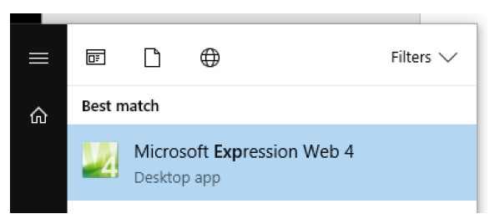

NOTE: When you run this program for the first time it may show a dialog box saying “Microsoft Expression Web is not currently your default Web page (HTML) editor. Would you like to make it your default editor? “you can safely click Yes to this.

- Click on File → New → Page

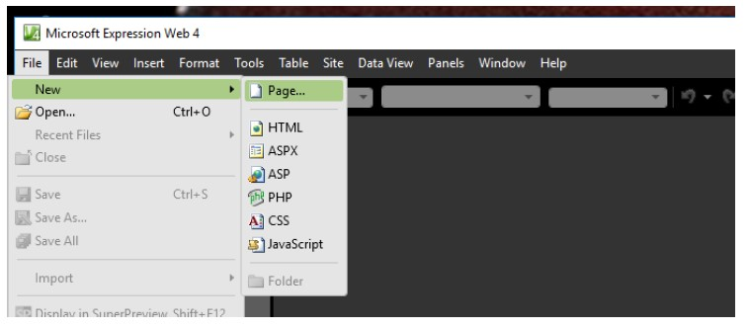

- In the ‘New’ dialogue window, select ‘General’ from the first column, select ‘HTML’ from the second column. Then click the ‘Page Editor Options…’ in ‘Options’ section below the Preview.

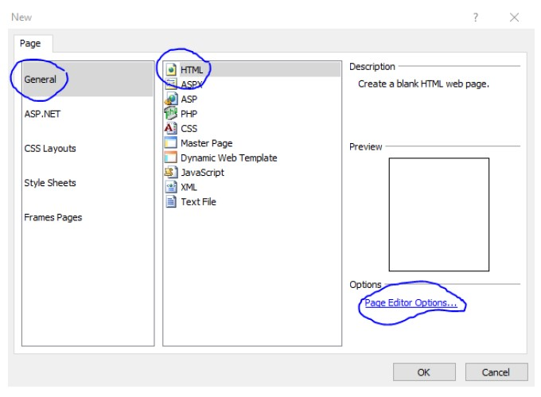

- In the Page Editor Options window, select “Authoring” tab, then set “Document Type Declaration (DTD)” to “HTML 5”. Leave CSS Schema version at 2.1. Click on OK.

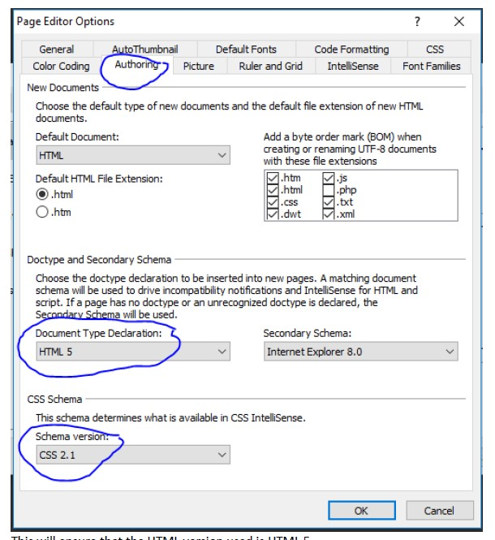

- Now, click OK to create a New HTML Page .
- This will open a new Untitled HTML file which already has the basic HTML structure of head, body, and so on. Click on File → Save, then type in index.html as file name for this main page file in the File Save dialog. Save this in a new directory / folder, e.g. IIT_Web_Task.
Note 1: During your Lab sessions it is recommended that you explore the interface of the Microsoft Expression Web. If you have any questions or concerns, please raise these with your tutor. You’re most welcome to use any other editor if this is your preference. Particularly, using a simple text editor will help you to learn coding much better than using the suggested editor.
Note 2: If you’re using the MS Expression Web, make sure to change the code view to ‘Split’ (see bottom mid-section of the HTML editor – image on next page) so you could see the actual code as well as the resulting web page design live.

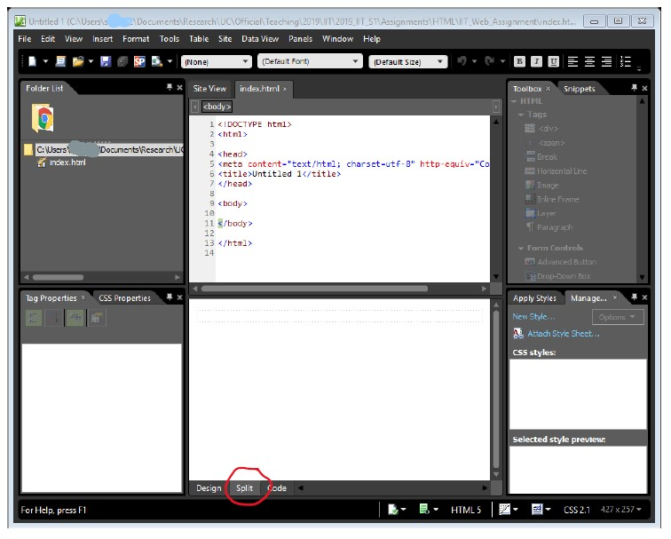

III A sample case study

This is your opportunity to compile everything you have learnt so far. Please, follow your lecturer’s guidelines when creating this simple webpage, as you will be undertaking the same steps to create your own.

Fish Creek Animal Clinic

Magda Patel is a veterinarian and owner of the Fish Creek Animal Clinic. Her customers are local pet owners who range from children to senior citizens. Magda would like a website to provide information to her current and potential customers. She has requested a home page, a services page, a page for advice from a veterinarian, and a contact page.

A site map for the Fish Creek Animal Clinic website is shown in figure below. The site map describes the architecture of the website, which consists of a “Home” page with three main content pages: “Services,” “Ask the Vet,” and “Contact.”

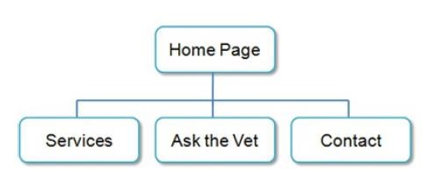
Figure below displays a wireframe sketch of the page layout for the website. It contains a header area, a navigation area, a main content area, and a footer area for copyright information.

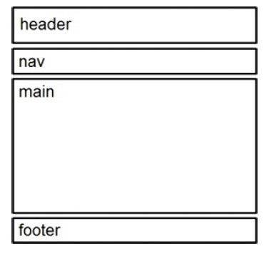
Fish Creek wireframe

You have three tasks in this case study:

- Create a folder for the Fish Creek website.
- Create the Home page: index.html.
- Create the Services page: services.html.

- Task 1: The Website Folder. Create a folder on your hard drive or portable storage device (USB stick) called “fishcreek” to contain your Fish Creek website files.

- Task 2: The Home Page. You will use a text editor application to create the Home page for the Fish Creek Animal Clinic website. The Home page is shown in Figure below.

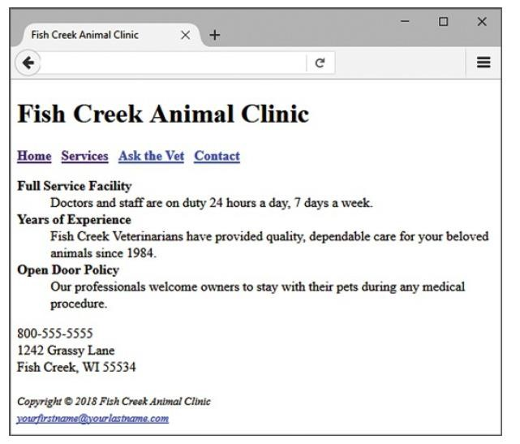
Fish Creek index.html

Launch MEW4, and create a web page with the following specifications:

- Web Page Title. Use a descriptive page title. The company name is a good choice for the home page of a business website. On pages other than the home page, the title typically contains both the company name and a word or a phrase that describes the purpose of the page.

- Wireframe Header. Code the header element with the text, “Fish Creek Animal Clinic” contained within a heading 1 element.

- Wireframe Navigation. Place the following text within a nav element with bold text (use the <b> element)

  - Home Services Ask the Vet Contact

  - Code anchor tags so that “Home” links to index.html, “Services” links to services.html,
“Ask the Vet” links to askvet.html, and “Contact” links to contact.html. Add extra blank spaces between the hyperlinks with the &nbsp; special character as needed.

- Wireframe Main Content. Code the main page content within a main element.

a) Code the following content in a description list. Configure the text in each dt element to have strong importance and display in bold font weight:

  - Full Service Facility
Doctors and staff are on duty 24 hours a day, 7 days a week.
  - Years of Experience
Fish Creek Veterinarians have provided quality, dependable care for your beloved animals since 1984.
  - Open Door Policy
Our professionals welcome owners to stay with their pets during any medical procedure.

b) Configure the following address and phone number contact information within a div element below the description list. Use line break tags to help you format this area.

  - 800-555-5555
  - 1242 Grassy Lane
  - Fish Creek, WI 55534

- Wireframe Footer. Code the following copyright and e-mail link information within a footer element. Format it with small text size (use the <small> tag) and italics font style (use the <i> tag).

  - Copyright © 2018 Fish Creek Animal Clinic
  - Place your name in an e-mail link on the line under the copyright.

Your page may seem a little sparse, but don’t worry; as you gain experience and learn to use more advanced techniques, your pages will look more professional. White space (blank space) on the page can be added with <br> tags where needed. Your page does not need to look exactly the same as the sample. Your goal at this point should be to practice and get comfortable using HTML.

Save your page in the fishcreek folder, and name it index.html.

  - Task 3: The Services Page. Create the Services page shown in figure below. A technique that improves productivity is to create new pages based on existing pages so that you can benefit from your previous work. Your new Services page will use the index.html page as a starting point.

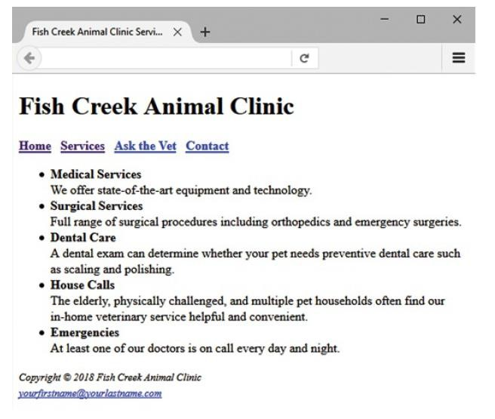

Open the index.html page for the Fish Creek website in MWE4. Select File > Save As, and save the file with the new name of services.html in the fishcreek folder. Now you are ready to edit the page.

- Web Page Title. Modify the page title. Change the text contained between the <title> and </title> tags to the following:

  - Fish Creek Animal Clinic Services

- Wireframe Main Content.

  - Delete the Home page content description list and contact information.
  - Use an unordered list to add the services content to the page.
  - Configure the name of each services category to use bold font weight and have strong emphasis. (Use the <strong> tag.) Use line break tags to help you configure this area. The service categories and descriptions are as follows:
  - Medical Services
We offer state-of-the-art equipment and technology.
  - Surgical Services
Full range of surgical procedures including orthopaedics and emergency surgeries.
  - Dental Care
A dental exam can determine whether your pet needs preventive dental care such as scaling and polishing.
  - House Calls
The elderly, physically challenged, and multiple pet households often find our in-home veterinary service helpful and convenient.

  - Emergencies
At least one of our doctors is on call every day and night.

Save your page and test it in a browser. Test the hyperlink from the services.html page to index.html. Test the hyperlink from the index.html page to services.html. If your links do not work, review your work, paying close attention to these details:

  - Verify that you have saved the pages with the correct names in the correct folder.
  - Verify your spelling of the page names in the anchor elements.

Test again after you make changes.

